# Cannonical-correlations-in-R-

How to do a simple canonical correlation in R.

## What are you Doing?

Canonical correlation is a technique that is not very popular in data science land because it is quite hard to interpret at times. However maybe someone brings it up or like me your professor likes the technique. If you are really curious UCLA has a great post and the script below is based on what they provided here: (https://stats.idre.ucla.edu/r/dae/canonical-correlation-analysis/)

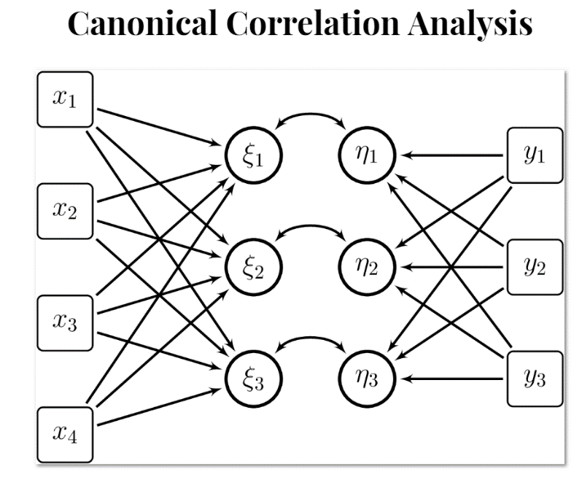

Figure representation of canonical correlation [source](http://my.ilstu.edu/~wjschne/444/CanonicalCorrelation.html#(4)).

### Assignment.

The dataset “paperpulp.csv” contains measurements on characteristics of pulp fibers and the paper made from them. X1-x4 correspond to paper characteristics, for which their full reference is given in the table below. Similarly, y1-y4 are the pulp fiber characteristics.